**NPJ’s Website**

**Cover Letter**

**How to use the website:**

1. Unzipped the file and open it.
2. Find index.html and open it in any internet browser.
3. You can navigate around the various pages (homepage, about us, order form, categories) by using the links on the sidebar on the right hand side.
4. Hove the mouse on the icons in the homepage to make the image larger.

Niamh White

* I specified the height and the width of the templates in HTML and CSS.
* I wrote the sentences in the ‘About Us’ section of the website.

Peter Barry

**X12112631**

* The web page below is the page I designed. You didn’t have a chance to mark it as I missed the presentation due to illness. It’s the categories page of the website.

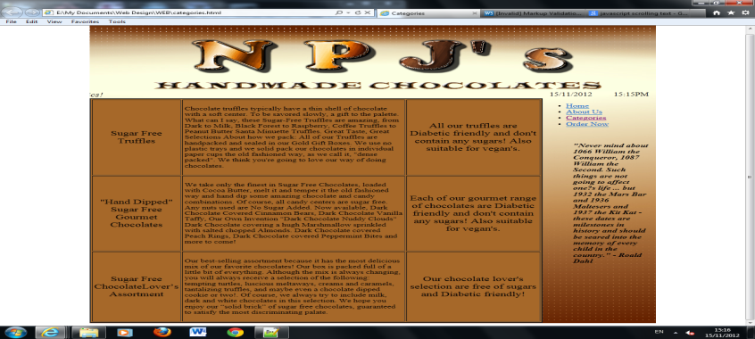

Joanna Bautista

**X12374571**

* I did the rest of the codes of the website.
* I have added the JavaScript code of Date and Time, Welcome Box(alert box), Atomatic Typing Text, Validation Form.
* Overall we have 5 pages, I have created a copy of homepage html and named it as index.html that includes a Welcome Box(Alert Box).
* I inserted the text that Barry created on the right hand side of the page on a scroll bar.
* I have also created an internal CSS on the homepage and index page about Slideshow.

Before After

